*Florida International University*

*School of Computing and Information Sciences*

Software Engineering Focus

Feature Document

User Story ID #659

**Name:** Mario Fidalgo

**Team Member(s):** Kyle Ryan

**Project:** Mobile Judge 9.0

**Product Owner(s)**: Masoud Sadjadi

**Mentor(s)**: Masoud Sadjadi

**Instructor**: Masoud Sadjadi

**User Story Name:** Bug: Fix issue with Location edit

* Description: As an admin, I would like to edit the student’s location, so that I can assign or modify the student’s current location easily.

Acceptance Criteria

* The location that is edited should be saved correctly after it is updated.

**Use Case**

* Name: Edit Location Field for a Project
* Actor: Admin
* Preconditions: User must be logged in as an admin and in the people’s view.
* Description <Flow of events>:

1. User double clicks on desired student they wish to edit.

2. System makes fields editable.

3. User modifies the location field.

4. System updates the location field in the database.

**Use Case Diagram**

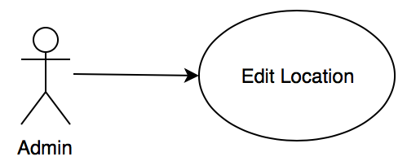

**Sequence Diagram**

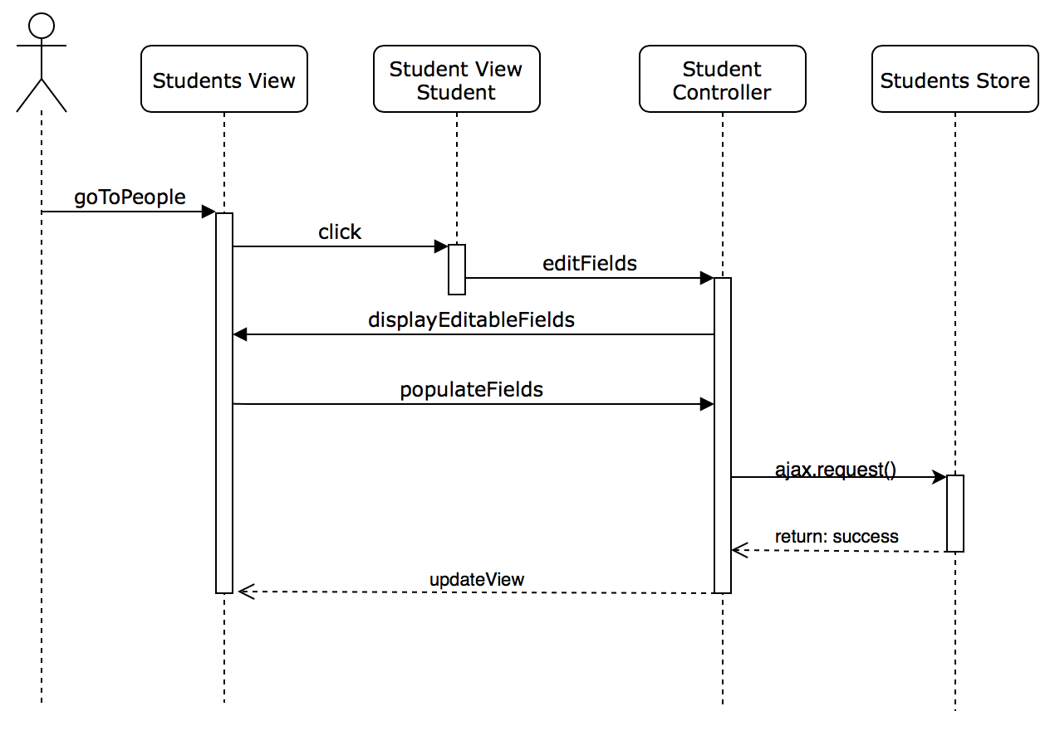

**Class Diagram**

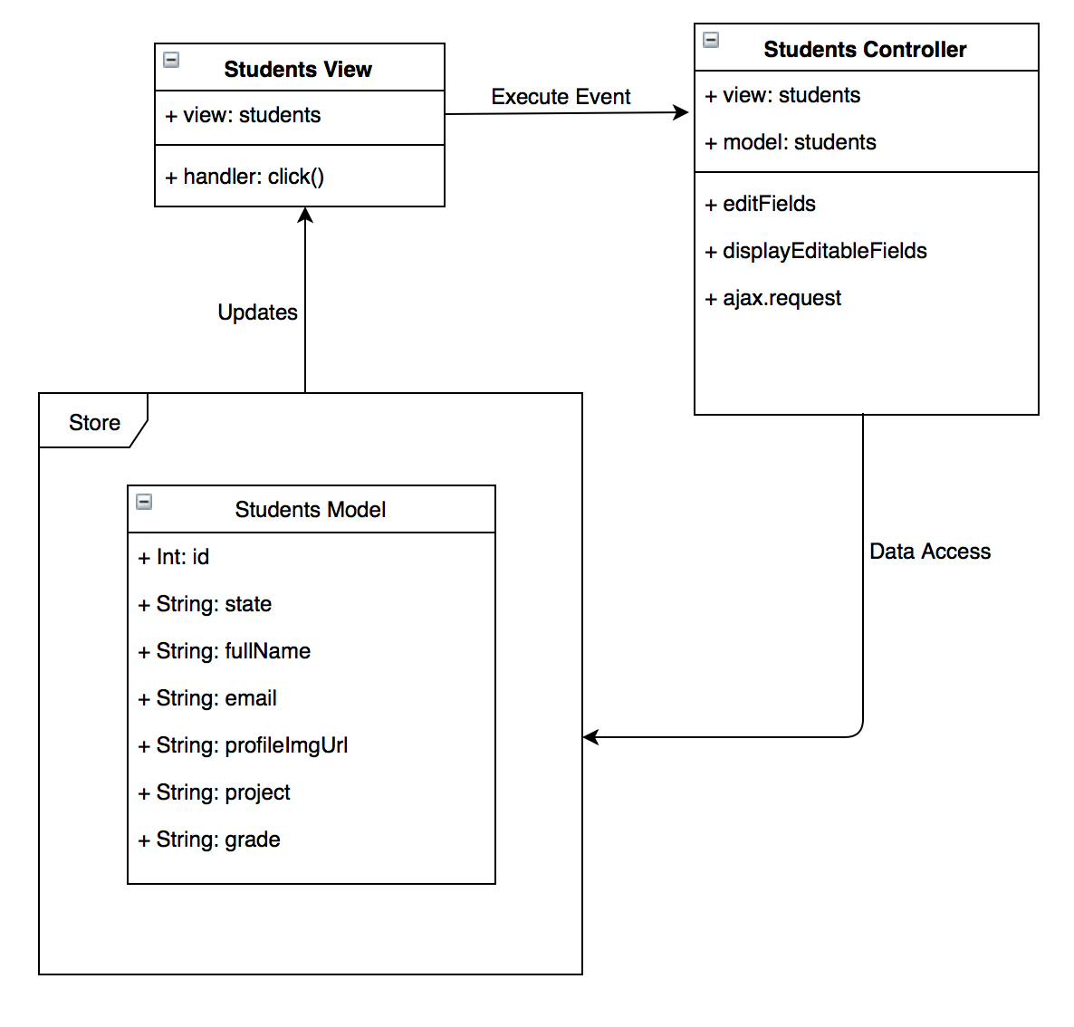

**Unit Test & Integration Test**

**Test case ID:** MJ-659-01

**Description/Summary of Test:** Change a student’s location information

**Precondition:** Admin is logged in and currently viewing the student’s tab in the people side tab. Then selects a students and clicks on the location field, and modifies their location.

**Expected Results:** If a zero is typed into the field, N/A should be shown as the location.

**Actual Result:** N/A appeared as the result.

**Status (Fail/Pass):** Pass

**Test case ID:** MJ-659-02

**Description/Summary of Test:** Change a student’s location information

**Precondition:** Admin is logged in and currently viewing the student’s tab in the people side tab. Then selects a students and clicks on the location field, and modifies their location.

**Expected Results:** If a number from 1-50 is typed into the field, the word “Location” and that number should be shown as student’s location.

**Actual Result:** All the numbers from 1-50 were type and the correct output was displayed and saved for the student

**Status (Fail/Pass):** Pass

**Test case ID:** MJ-659-02

**Description/Summary of Test:** Change a student’s location information

**Precondition:** Admin is logged in and currently viewing the student’s tab in the people side tab. Then selects a students and clicks on the location field, and modifies their location.

**Expected Results:** If a number from not from 1-50 is typed into the field, the word “Location” and that number should be shown as student’s location.

**Actual Result:** The record’s value would change but since the code wasn’t valid it would disappear from the view.

**Status (Fail/Pass):** Fail

**Visual User Guide**

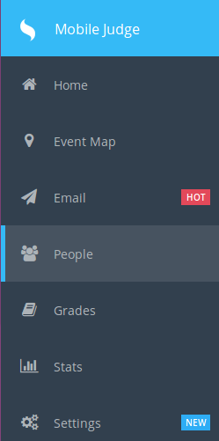 First go to the People tab on the left side of the screen, and a list of students should appear in the student’s tab.



Then click on a student to modify their information and click on the location field and type any number

.